Field Day at the Nursery Research Center
Exhibitor/Sponsor Application

472 Cadillac Lane
McMinnville, TN 37110
May 16, 2024
9:00 am – 2:00 pm
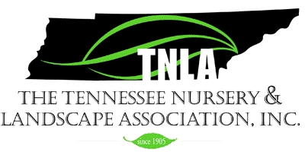

If you are looking for the latest industry news or new products, services and/or equipment, join us for our Field Day at the Otis Floyd Nursery Research Center in McMinnville, TN. Lunch will be provided, as well as pesticide points. Please send your sponsorships and/or exhibit requests ASAP. Exhibit space is limited. Applications MUST be received no later than April 25th to be included on event signage.

Company Name:___________________________________ Contact: _____________________
Address: ______________________________________________________________________
Phone: _____________________ Email: ____________________________________________
_____Gold Sponsor - $500.00
- Listed as a Gold Sponsor of the event on signage at Field Day and in email blasts
- Complimentary table display
- Company logo on TNLA’s website, monthly newsletter, social media accounts, and in The Greentimes magazine
_____Silver Sponsor - $250.00
- Listed as a Silver Sponsor of the event on signage at Field Day and in email blasts
- Display company banner at Field Day (provided by you)
- Listed as a sponsor on TNLA’s website, monthly newsletter and in The Greentimes magazine
_____Bronze Sponsor - $100.00
- Listed as a Bronze Sponsor of the event on signage at Field Day and in email blasts
- Listed as a sponsor in monthly newsletter and The Greentimes magazine

Exhibit Space:
_____30 x 30 Space - $300.00 _____10 x 10 Table Display - $150.00
You can demonstrate equipment, such as digging, etc.
Booths will be assigned according to when application and payment are received.
Make checks payable to TNLA
PO Box 57 McMinnville, TN 37111 – (931)473-3951
THANK YOU FOR YOUR SUPPORT!

